Business address:  HSL, s.r.o.  Púchovská 8  831 06 BRATISLAVA | 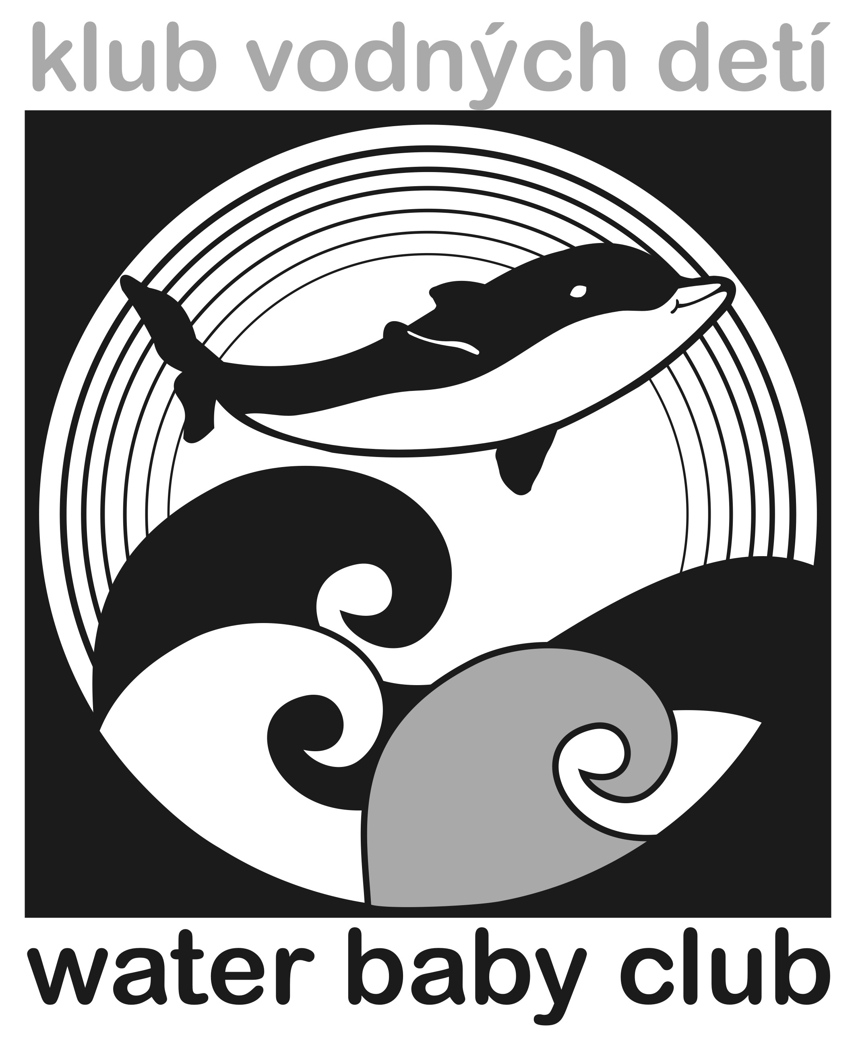 | Swimming Center  water baby club  Banšelova 4  821 04 BRATISLAVA  tel.: +421 (911) 860 688  e-mail: bratislava@wbc.sk  www.waterbabyclub.sk

DOCTOR’S CONFIRMATION ABOUT THE CHILD’S HEALTH CONDITION

I hereby confirm that the child ..............................................................................................

child’s identification number .............../........ is currently healthy and can take part in the "swimming" course for children of the age up to three years old organized by the Center.

__________________ ______________________________________
doctor’s phone number date and doctor’s signature and stamp

